**PotPal**

UI Prototype

Version 1.0

Revision History

| **Date** | **Version** | **Description** | **Author** |
| --- | --- | --- | --- |
| 11/12/24 | 0.1 | Added Introduction | Lê Thanh Minh Trí |
| 11/12/24 | 0.2 | Added UI Images of each Page | Lê Thanh Minh Trí |
| 11/12/24 | 0.3 | Added detail and descriptions of each Page | Lê Thanh Minh Trí |
| 11/12/24 | 1.0 | First version | Lê Thanh Minh Trí |

Table of Contents

**1. Introduction 4**

**2. The Navigation Bar 8**

Purpose 8

Description 8

How Users Can Use 8

**3. Customer Home Page 9**

Purpose 10

Description 10

How Users Can Use 10

**4. About Us Page 11**

Purpose 11

Description 11

How Users Can Use 11

**5. Contact Page 12**

Purpose 12

Description 12

How Users Can Use 12

**6. Login Page 13**

Purpose 13

Description 13

How Users Can Use 13

**7. Register Page 14**

Purpose 14

Description 14

How Users Can Use 14

**8. Searching Pages 15**

Purpose 15

Description 15

How Users Can Use 15

**9. Admin Page 16**

Purpose 17

Description 17

How Users Can Use 17

**UI Prototype**

# Introduction

* This document provides an overview of the **PotPal** UI prototype, outlining key features and functionalities of the user interface.
* Describes various pages within the application, such as **Customer Home Page**, **About Us**, **Login**, **Register**, **Search**, etc.
* Each page is detailed in terms of its purpose, content, and user interaction, describing how users will navigate and utilize the platform.
* This UI prototype serves as a foundational guide for the development and design of the PotPal application, ensuring a user-friendly experience and efficient management capabilities.

**Note 1:** This sketch in Figma: <https://www.figma.com/design/q2zlzrpgcmybAueTF0t79n/Untitled?node-id=0-1&t=oU8Aym2NkMcQTNCr-1>

is no longer used and has recently been discarded. Here is some preview images:

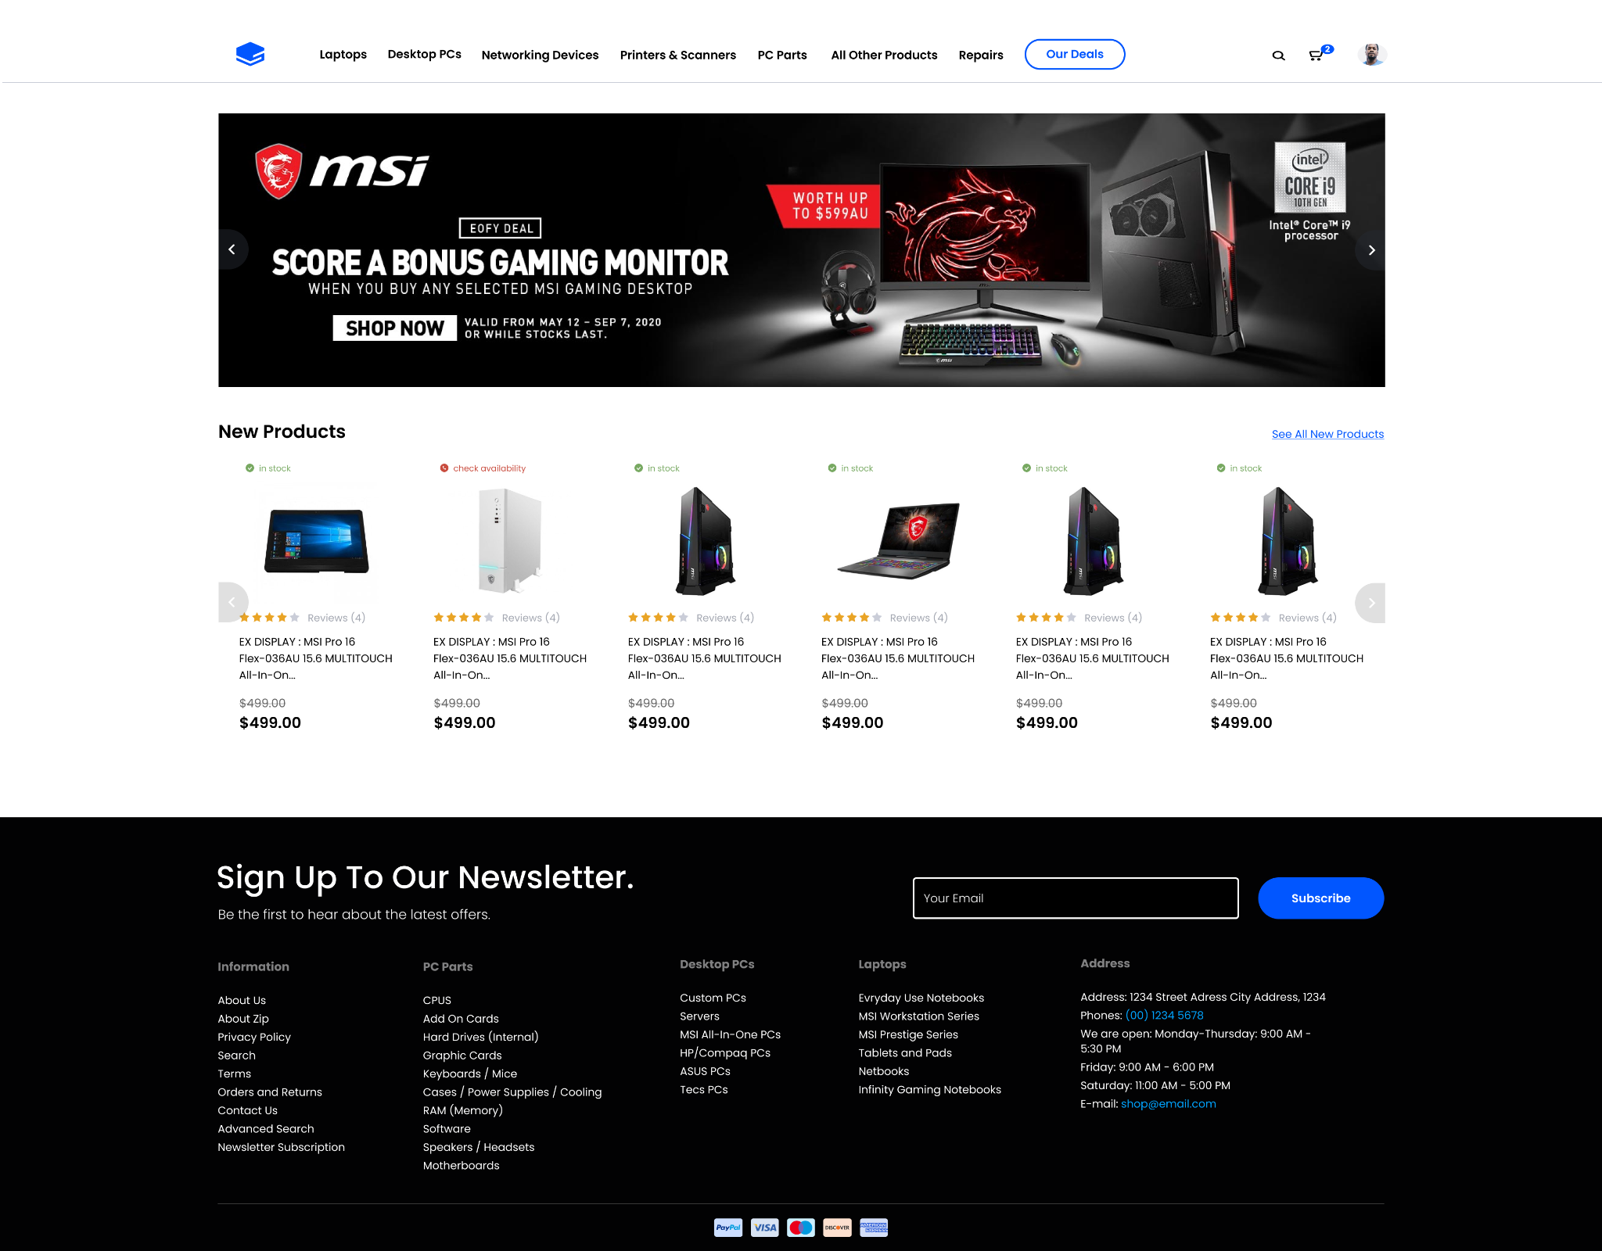

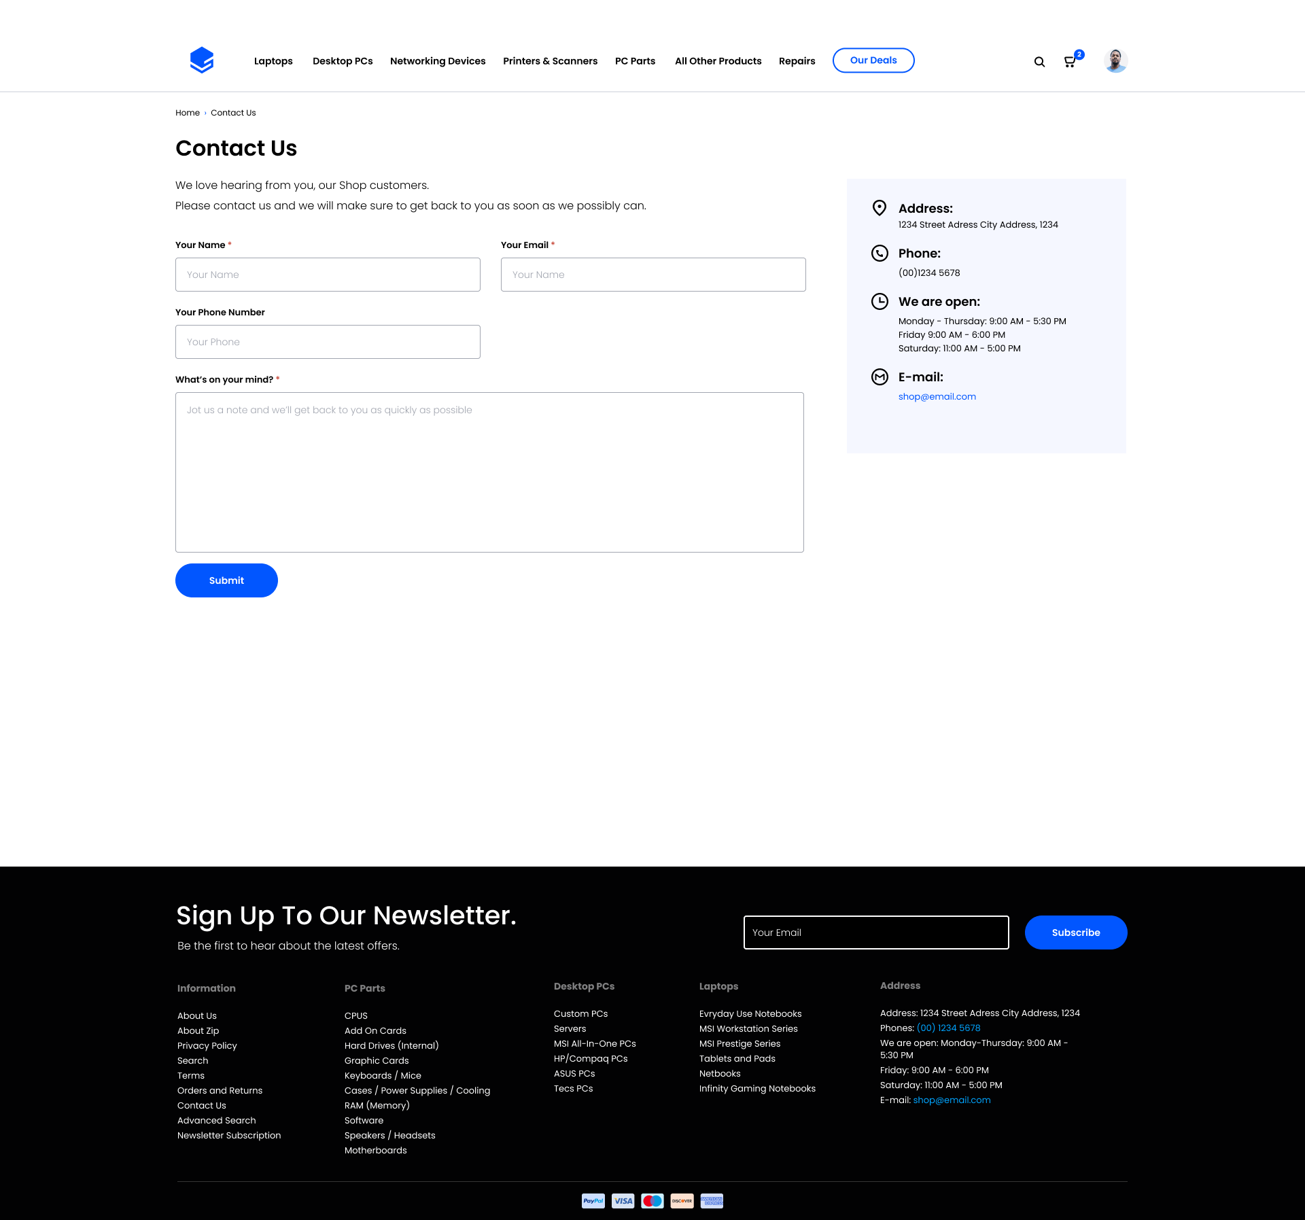

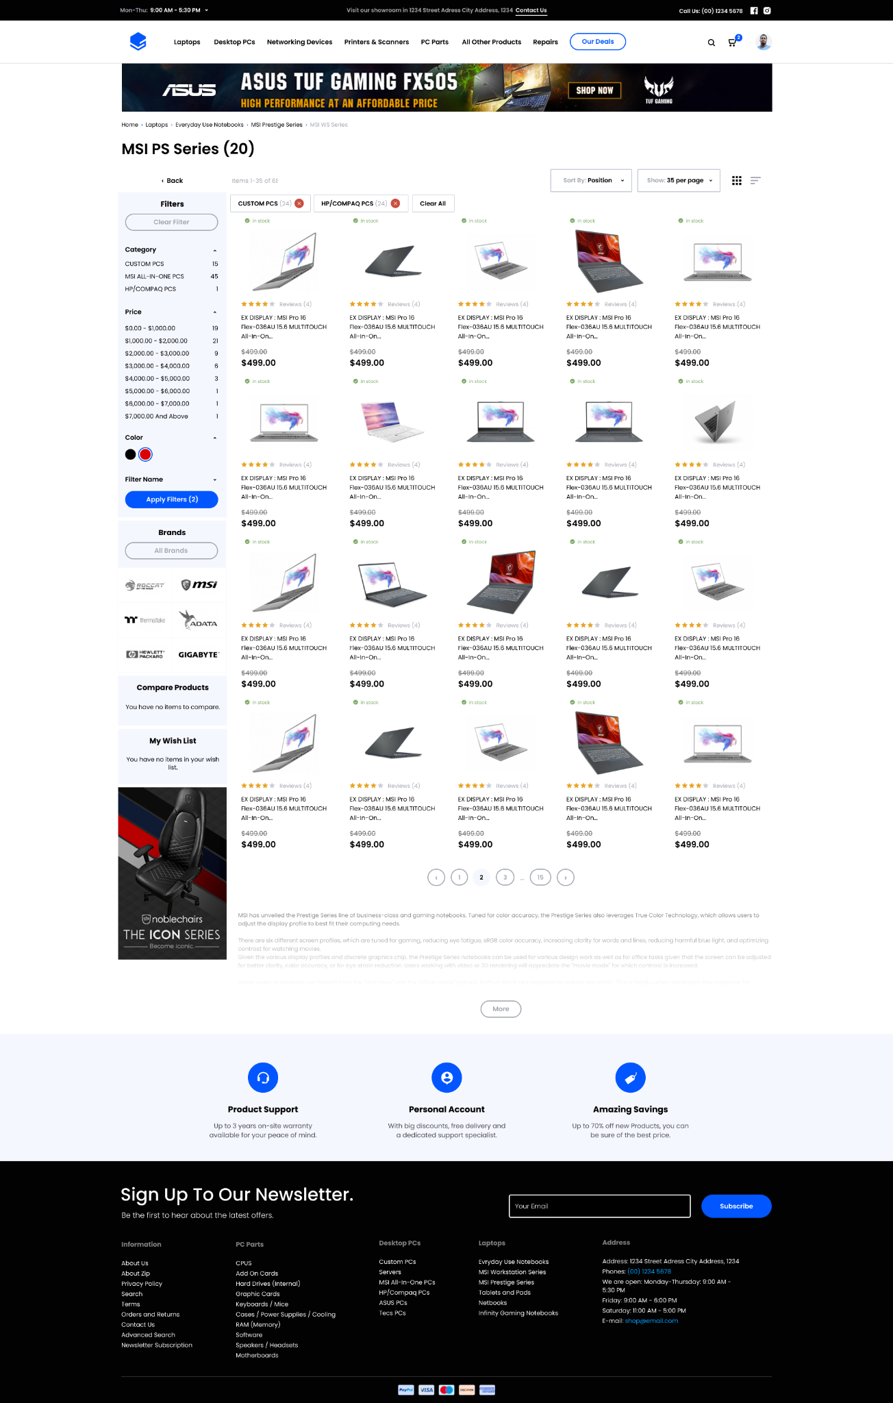

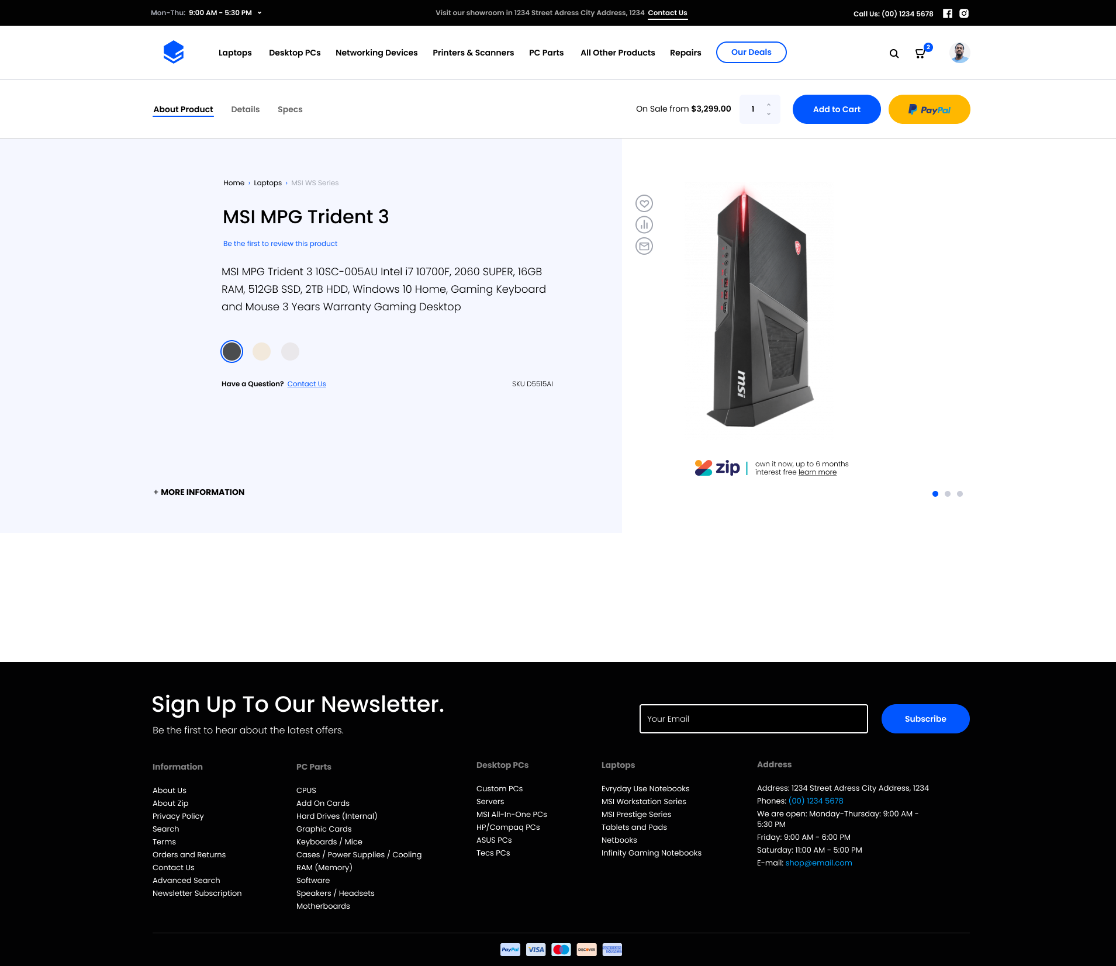

**Note 2:** The version used in this document is an early version produced by in-production source code. This version is more fleshed out and relevant than the previous sketch.

# The Navigation Bar



*Image 1: The Navigation Bar*

## Purpose

**The Navigation Bar** acts as a global and centralized menu to help users quickly access different sections of the platform without needing to search or scroll through content. It ensures consistent and straightforward navigation.

## Description

* **Options:** Includes links to core pages such as Home, About Us, Contact, Login, Register, and other key features of the system. (Cart, Account Management will be unlocked after logging in)
* **Search:** A search bar for users to locate items quickly.
* **Categories:** A quick search feature enabling users to filter items with the selected category.

## How Users Can Use

* Click on menu items to navigate to corresponding pages.
* Use the search bar to find specific information.
* Use the Categories drop down menu to quickly search and filter items.
* For logged-in users, access account-related actions like viewing or updating profiles.

# Customer Home Page

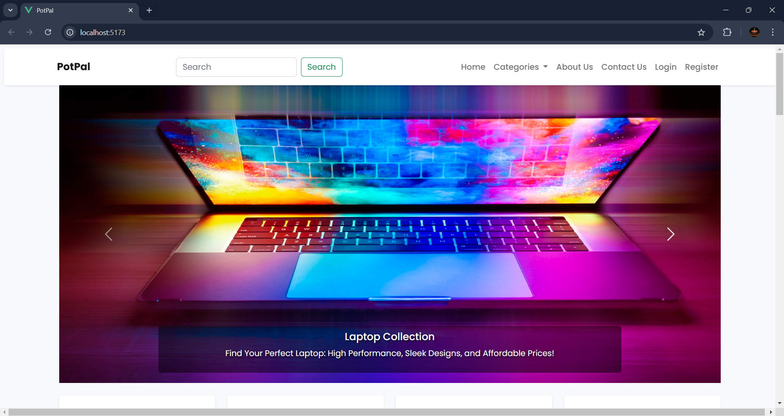  
*Image 2: Welcome banners for advertising*

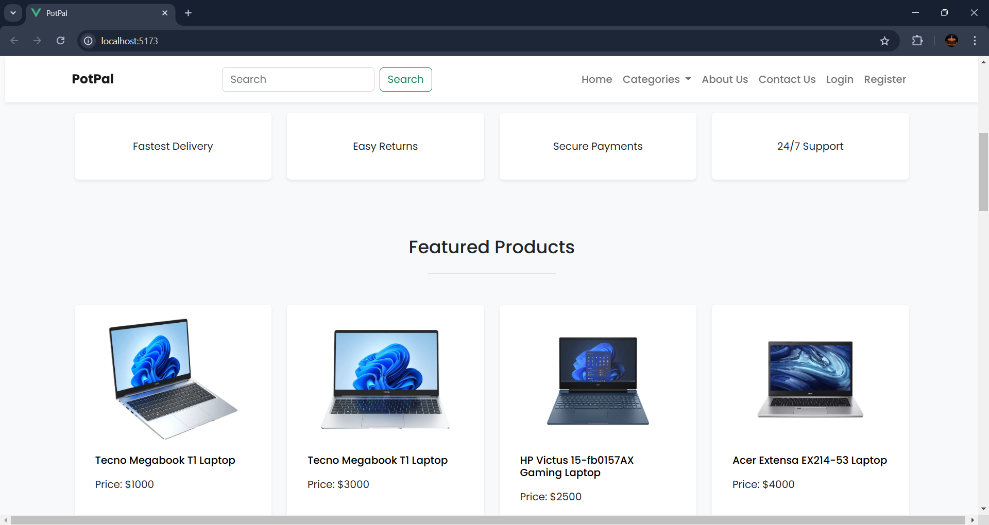  
*Image 3: Section to advertise Featured Products*

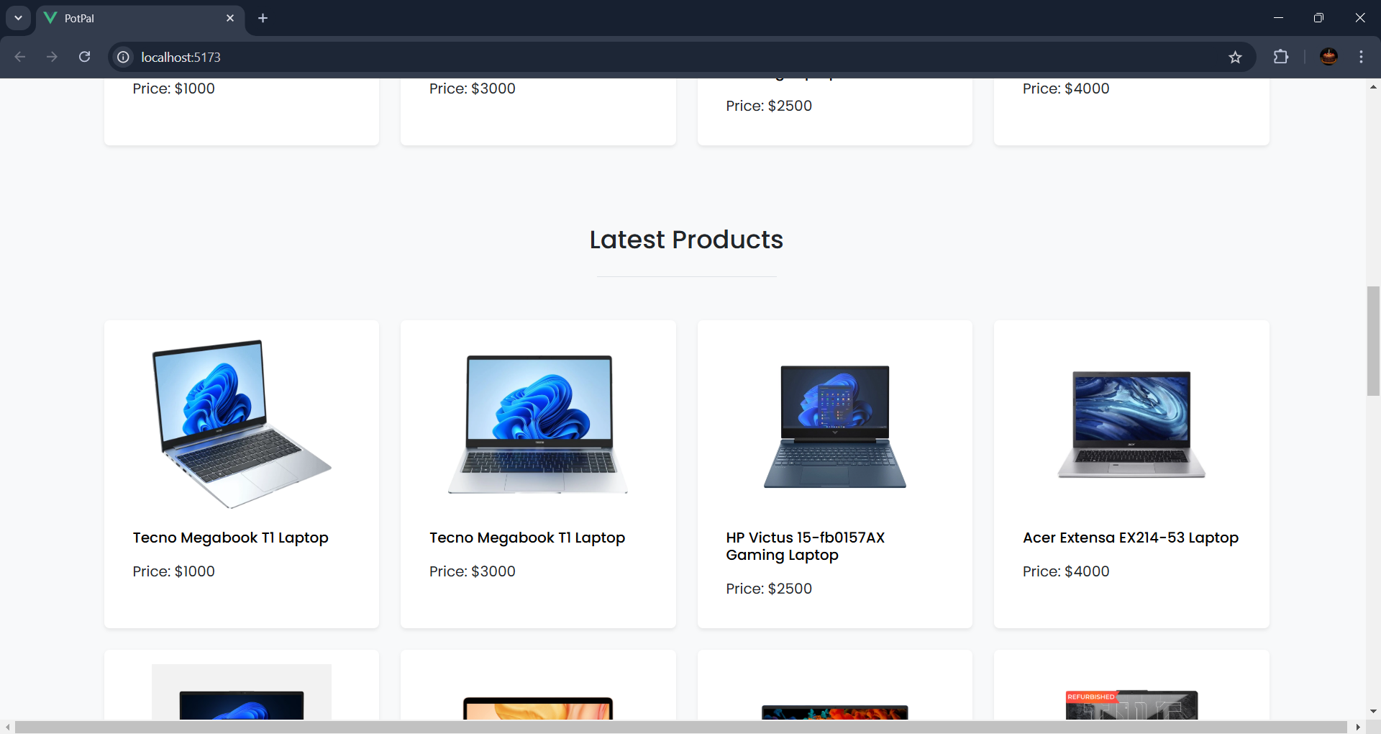  
*Image 4: Section to advertise Latest Products*

## Purpose

The **Customer Home Page** serves as the landing page for guests visiting the system (not required to sign in).   
It is used mainly for advertising and familiarizing the guests with the interfaces. The Home Page will pick out popular and latest products to advertise to the guests.

## Description

* **Welcome Banners:** A slideshow of images and captions to welcome browsing guests, can also be used for advertising purposes..
* **Featured Content:** Highlights or recommendations based on user preferences or recent activity (e.g., popular products, featured services) or based on the store’s needs.
* **Latest Content:** Newly added products will show here to update guests on latest products.
* **User Account Info (if logged in):** Displays the user’s name and account status, possibly with access to account settings or logout options.

## How Users Can Use

* View advertisement or announcements from the Welcome Banners.
* Users can browse to see what’s in store, checking out the latest and popular products.

# About Us Page

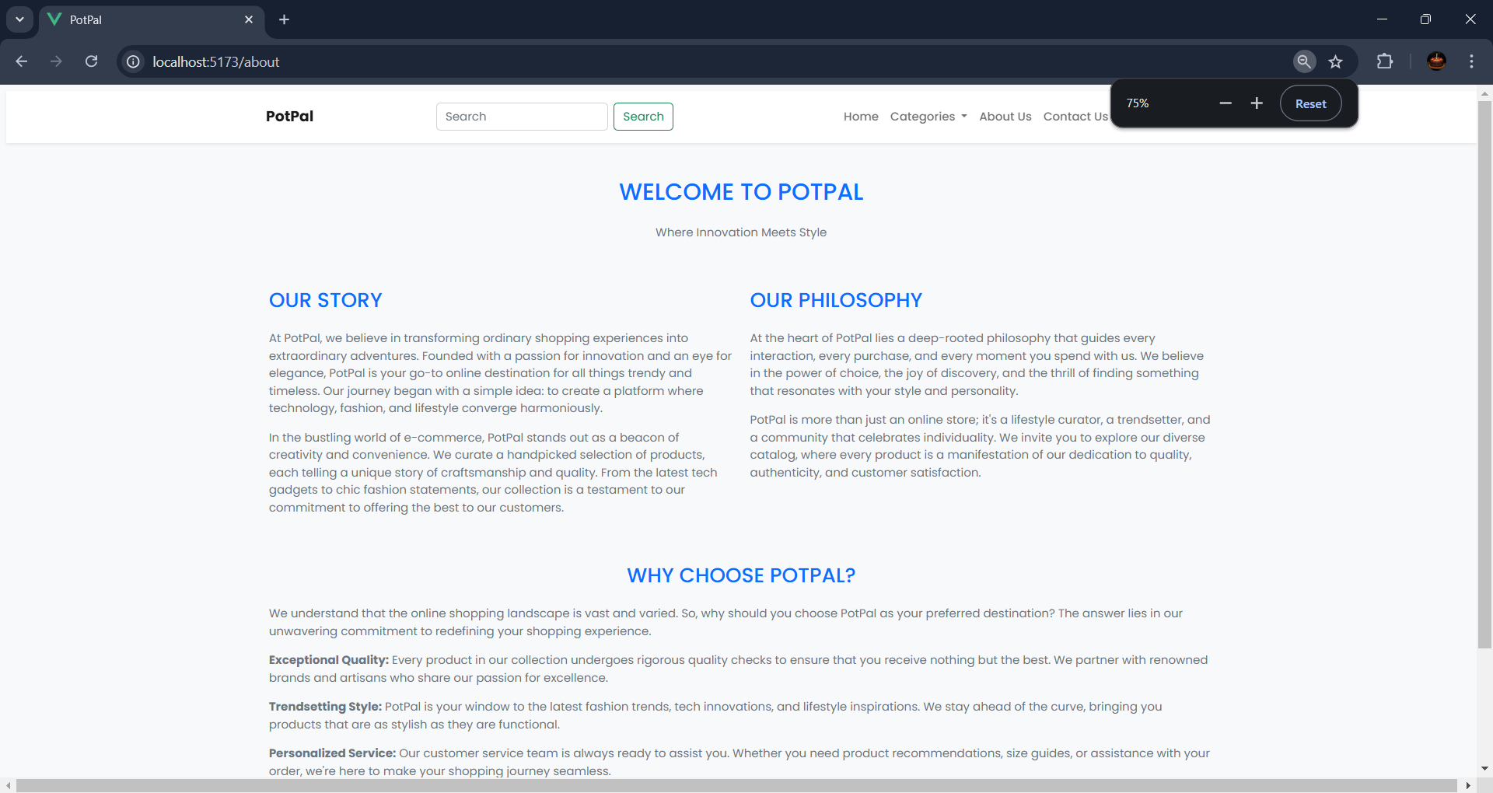

*Image 5: About Us Page*

## Purpose

The **About Us** page provides users with information about the organization, its mission, vision, values, and history. This page aims to build trust and establish a connection with users by showcasing the company’s background and objectives.

## Description

* **The Organization:** A brief overview of the company, including its mission and vision statements.
* **Company History:** A timeline or narrative outlining significant milestones and achievements.
* **Multimedia Content:** Images, videos, or infographics that enhance the storytelling of the organization’s journey.

## How Users Can Use

* Learn about the company’s purpose and values.
* View details about leadership or team members.

# Contact Page

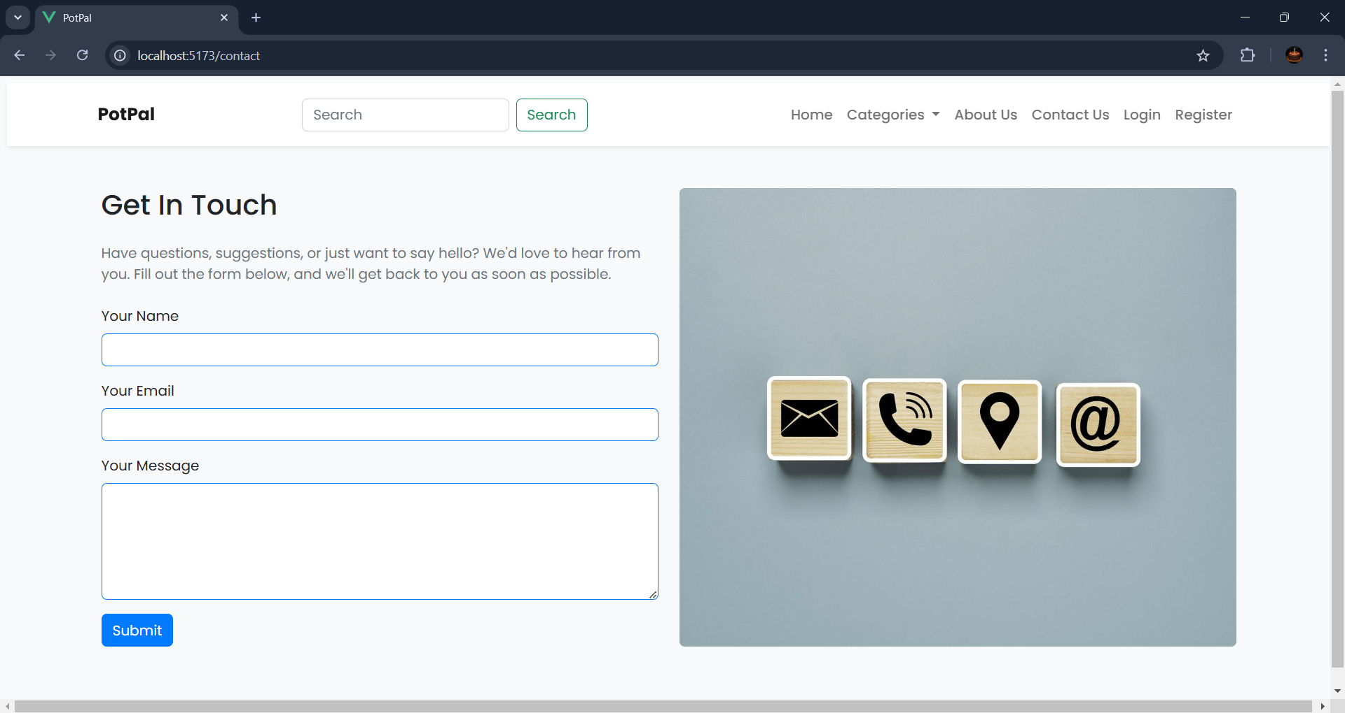

*Image 6: Contact Us Page*

## Purpose

The **Contact Page** allows users to communicate with the organization, providing a platform for inquiries, feedback, or support requests. It serves as a bridge between users and the company.

## Description

* **Contact Form:** Fields for users to enter their name, email, subject, and message.
* **Contact Information:** Displays the company’s address, phone number, email address, and business hours.

## How Users Can Use

* Fill out and submit the contact form to send inquiries or feedback.
* Use the provided contact details to reach the organization directly via phone or email.

# Login Page

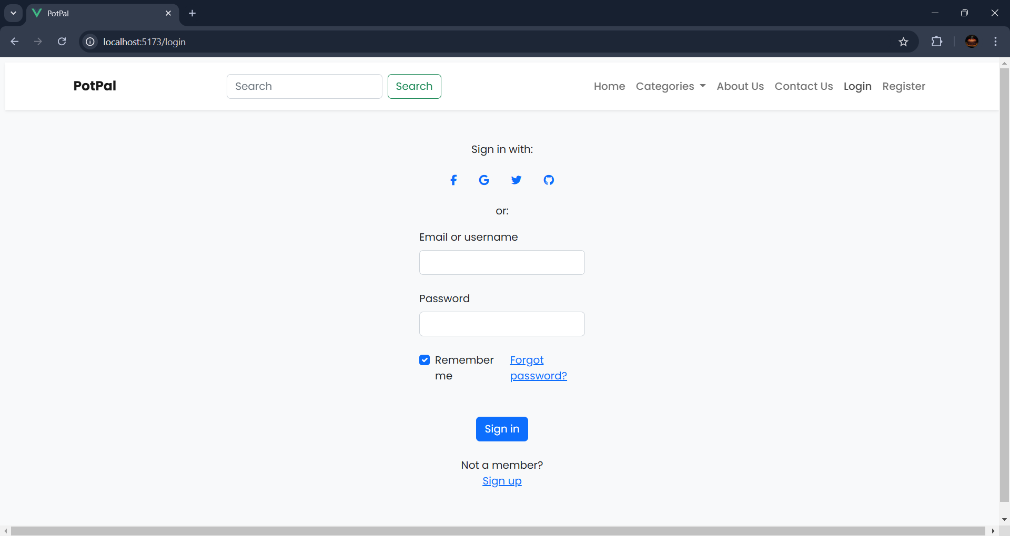

*Image 7: Login Page*

## Purpose

The **Login Page** allows users to securely access their accounts by entering their credentials. It is designed to authenticate users and grant access to personalized features of the platform.

## Description

* **Username/Email Field:** A text box for users to input their registered email or username.
* **Password Field:** A secure input box for users to enter their password.
* **Login Button:** A button to submit credentials and proceed to their account dashboard.
* **Forgot Password Link:** A link to initiate password recovery for users who cannot remember their credentials.
* **Sign-Up Link:** A quick navigation option for new users to register an account (if they don’t have one).

## How Users Can Use

* Enter their registered email/username and password to sign in.
* Click the **Login** button to access their account.
* Use the **Forgot Password** link to reset their password if necessary.
* Navigate to the **Sign-Up** page to create a new account if they are not already registered.

# Register Page

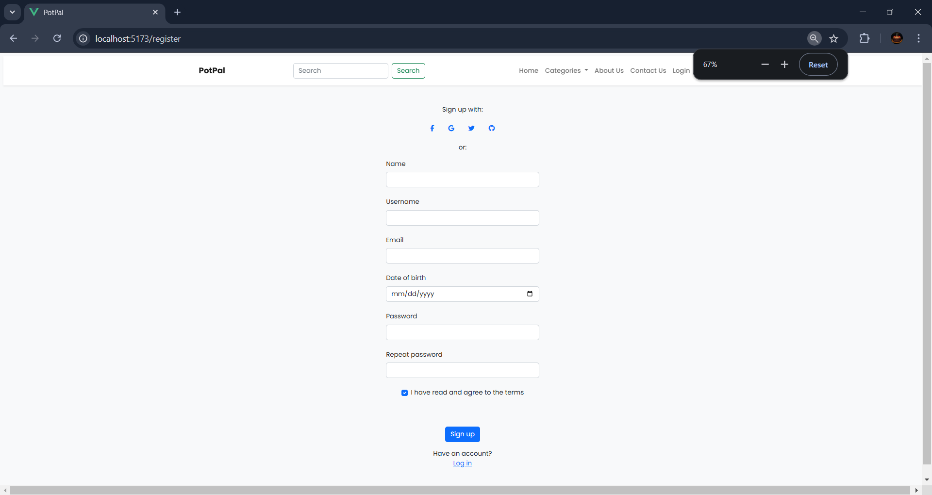

*Image 8: Register Page*

## Purpose

The **Register Page** allows new users to create an account on the platform. It gathers necessary details to set up a user profile and provides access to platform features.

## Description

* **Personal Information Fields:** Input fields for name, username and email address.
* **Password and Confirm Password Fields:** Secure input fields for setting and confirming a password.
* **Terms and Conditions Checkbox:** A checkbox to agree to the platform’s terms and conditions (often linked for review).
* **Sign-Up Button:** A button to submit the registration form.
* **Login Link:** A quick navigation option to the login page for users who already have an account.

## How Users Can Use

* Fill out all required fields with accurate personal information.
* Set a secure password and confirm it to ensure accuracy.
* Check the terms and conditions box to acknowledge the agreement.
* Click the **Sign-Up** button to submit the form and create an account.
* Use the **Login** link to return to the login page if already registered.

# Searching Pages

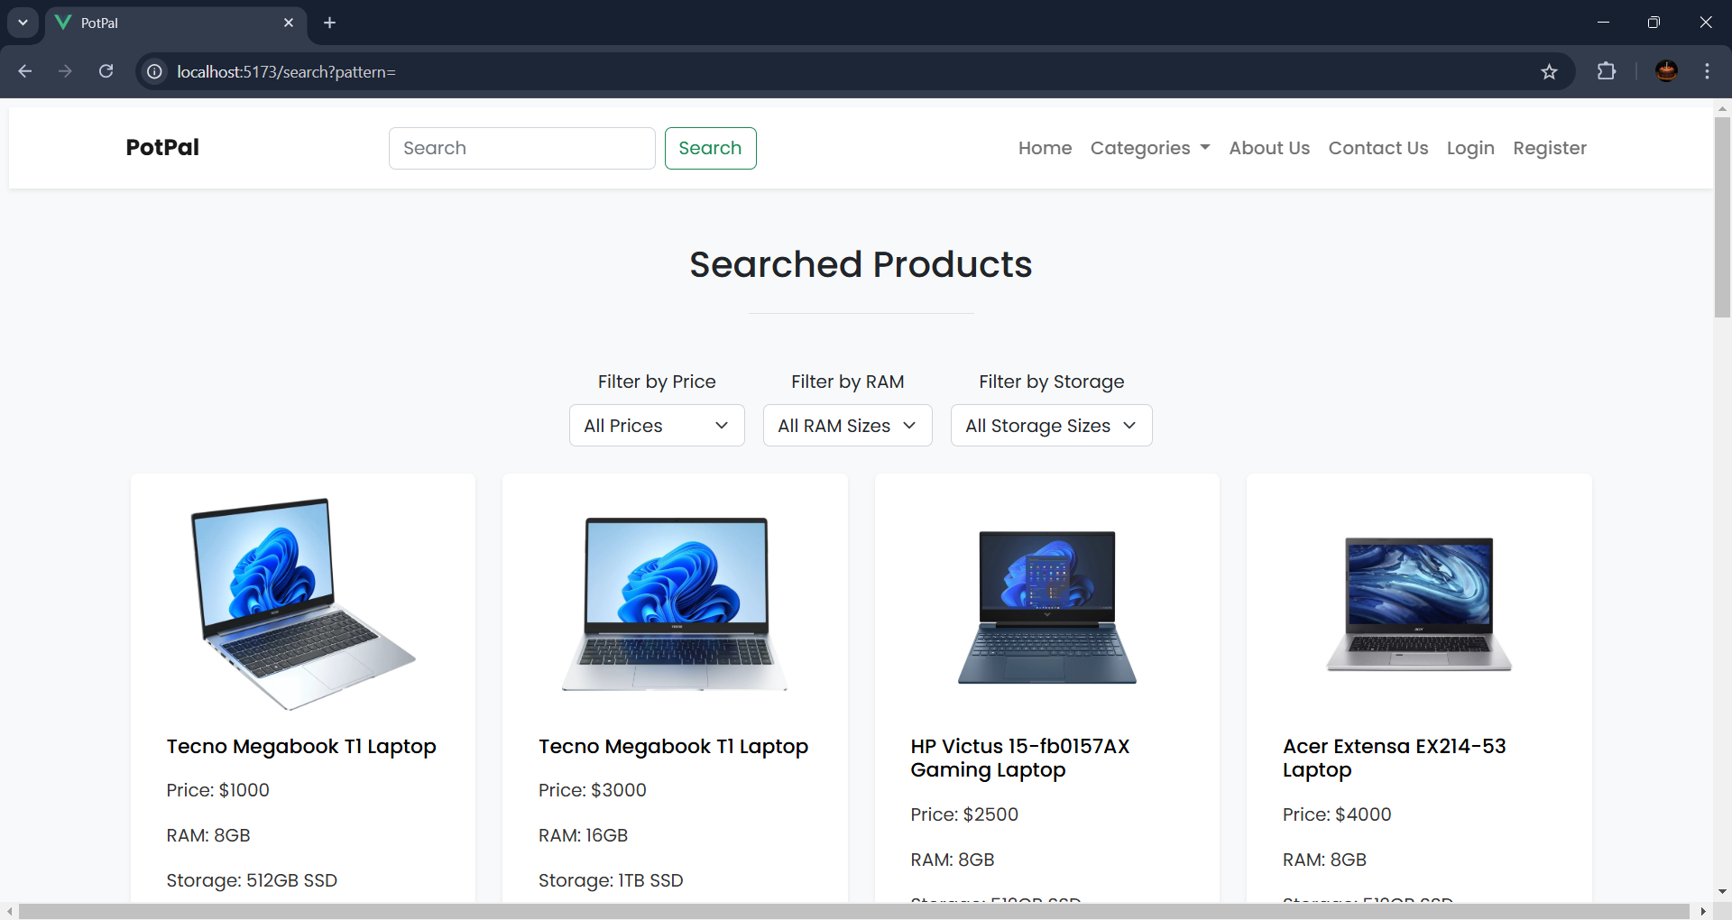

*Image 9: Product Search Pages*

## Purpose

The **Searching Page** enables users to find specific information, products, or content within the platform by entering relevant keywords or filters. These pages are designed for quick and efficient navigation to the desired results.

## Description

* **Search Bar** (Navigation Bar)**:** A prominent field where users can type their search queries.
* **Filter Options:** Categories, price ranges, ratings, or other criteria to refine the search results.
* **Search Results Section:** A dynamic area displaying the results based on the entered query, in grid format.

## How Users Can Use

* Enter a keyword or phrase into the search bar and press Enter or click the **Search** button.
* Use filters to narrow down the results based on specific preferences.
* Review the search results and click on an item for more details or to proceed with actions like viewing, purchasing, or saving.

# Admin Page

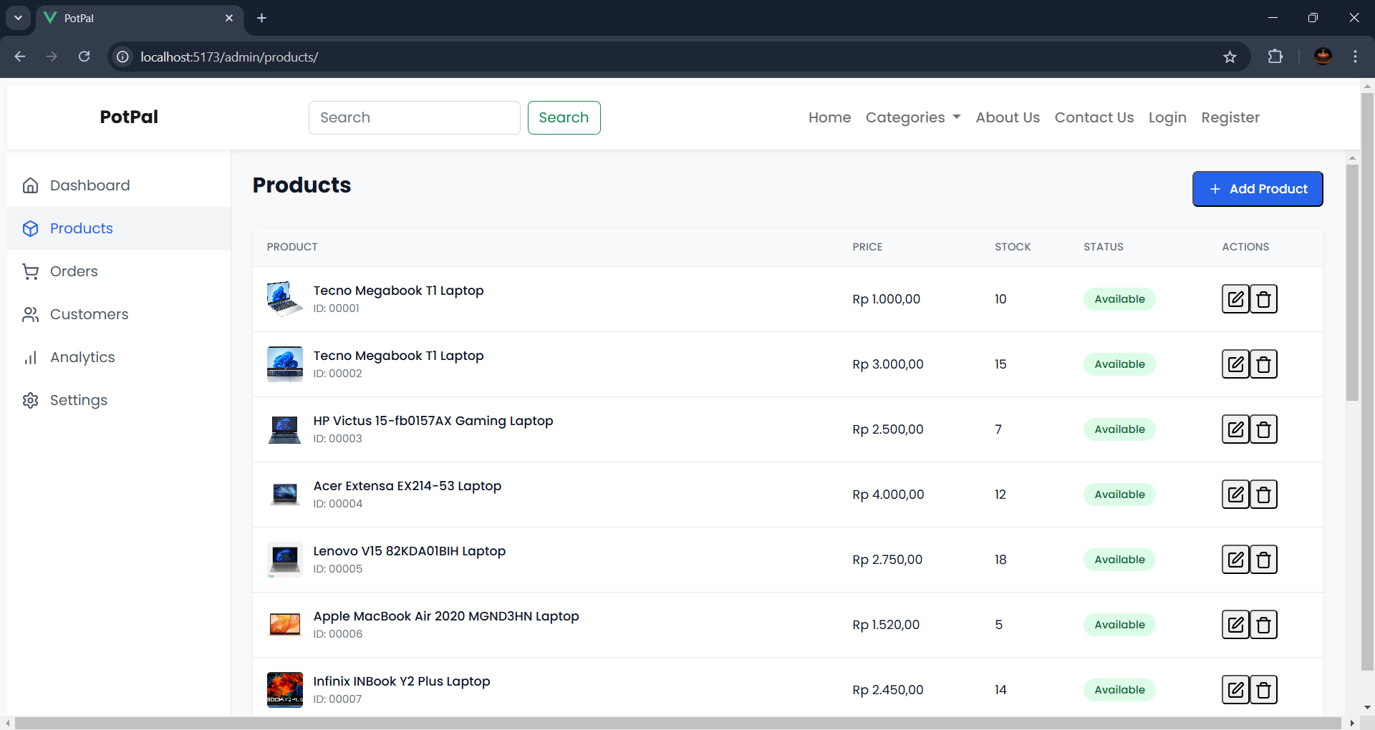

*Image 10: Product Managing Page (Admin)*

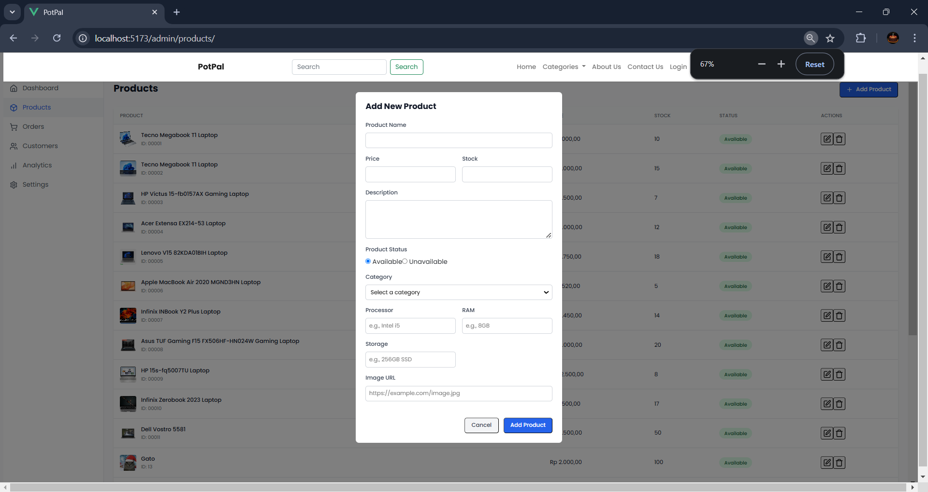

*Image 11: Product Add New Submit Form*

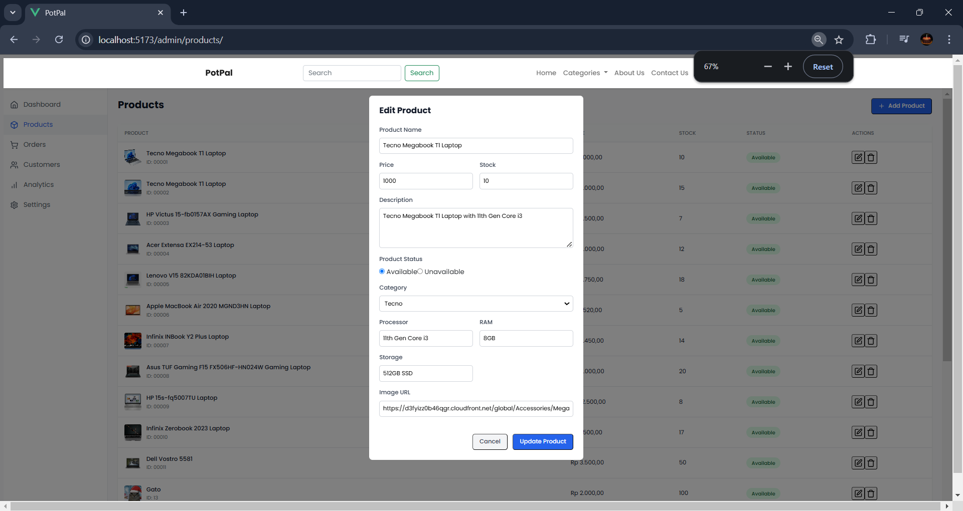

*Image 12: Product Edit Submit Form*

## Purpose

The **Admin Page** provides administrative users with tools to manage the platform, oversee user activities, and maintain the system. It is designed to give admins control over the application’s content, settings, and customer management.

## Description

* **Dashboard:** Summary view with key metrics such as user statistics, profit statistics or recent activity logs.
* **User Management Section:** Tools for viewing, editing, or deleting user accounts. Also able to view the user's purchase history.
* **Content Management Tools:** Features for adding, editing, or removing products and categories..
* **System Settings:** Options to configure platform settings, such as security, notifications, or integrations.
* **Reports and Analytics:** Visualizations reports of user behavior, sales, or other relevant data.
* **Support or Feedback Panel:** Access to support tickets, user feedback, or issues raised by customers.

## How Users Can Use

* View the dashboard to monitor system metrics and user activity.
* Manage user accounts, including resetting passwords or adjusting roles.
* Add, update, or delete content to keep the platform up to date.
* Configure settings to align the platform’s functionality with organizational needs.
* Generate reports to gain insights into platform performance and user engagement.
* Address customer queries or complaints via support tools.